ASR 4380
Date: 2014.04.14
Description: to allow input of Delivery notes up to maximum 13 chars.
Current maximum set as 10 char.

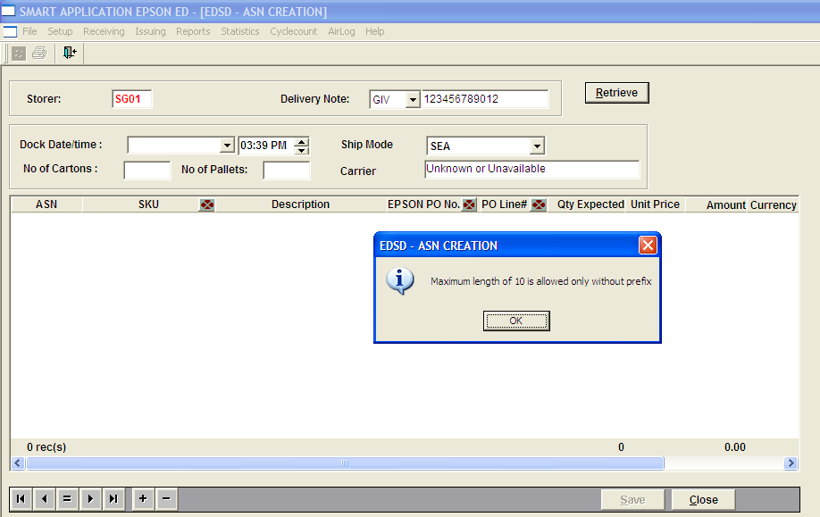

SAP system allows maximum length of 16 char
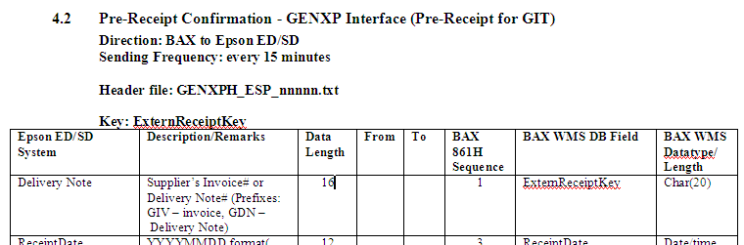

Finalize ASN Screen:
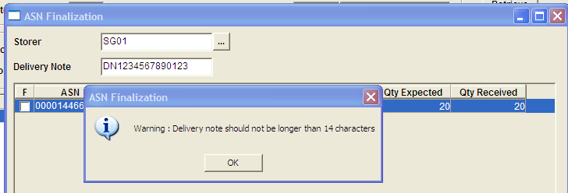
TO change the total length of DN from 14 to 16 chars. (3 prefix + 13 DN)

Changes:
ASN:
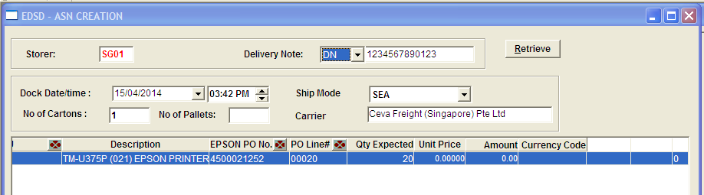

ITS:

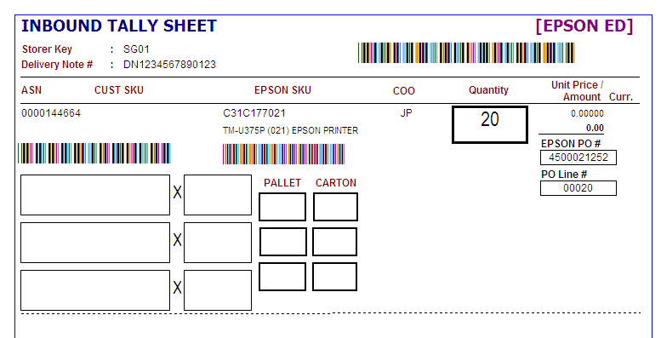

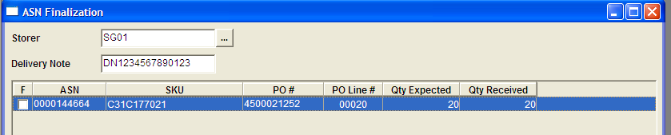

Sample generated 861 file
